Introduction to Deep Learning
Tutorial 2
- When we talk about deep learning neural networks, we have to start with the traditional neural networks (NNs), which are also called artificial neural networks (ANNs).
- Traditional neural networks are computer simulations of biological neural networks in the human brain.
- The concept of neural networks was first developed by American neurophysiologist Warren McCulloch and American logician Walter Pitts in 1943.
- A biological neural network is a network of interconnected neurons. The biological neuron typically consists of a cell body, dendrites, and an axon. The cell body is also called the soma, while dendrites and axon are filaments that extrude from it. The dendrites typically extrude a few hundred micrometres from the soma, while the axon can be up to a meter long. At the end of the axon are the axon terminals, and each terminal is connected to another neuron by the synapse. For each neuron the dendrites are the inputs from other neurons, and the axon is the output to other neurons. A human brain typically has 100 billion neurons.
- There are three types of neurons: sensory neurons respond to stimuli such as touch, sound, or light and send signals to the brain.
- Motor neurons receive signals from the brain to control muscle.
- Interneurons connect neurons to other neurons.
- Artificial neurons take input signals, multiply them by weights, add them together, and then pass them to a nonlinear activation function for output.
- The activation function of a node defines the output of that node as a function of an input or a set of inputs.
- Similar to biological neuron networks, artificial neural networks consist of interconnected artificial neurons. They usually have three layers: an input layer, an output layer, and a hidden layer.
- The reason they have only one hidden layer is that the computation complexity increases as the number of layers increases.

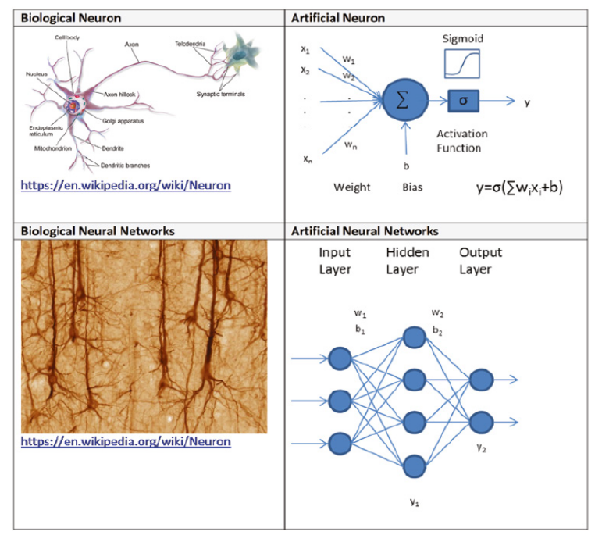

- To train an artificial neural network, we first initialize the neural network’s weights randomly, and then we feed the network a set of training data, with certain inputs and outputs.
- Each time the network produces an output from the inputs, it uses a loss function to compare the computed output with the desired output and then returns the differences, called errors, to the network to adjust the weights accordingly.
- This is called backpropagation, short for “backward propagation of errors.”
- The weights are adjusted according to the errors using a method called gradient descent, which calculates the gradient of the errors with respect to the neural network weights and adjusts the weights to reduce the errors.
- This process is then repeated many times until the neural network weights are stabilized. Training an artificial neural network is essentially an optimization problem.
- Gradient descent is a commonly used iterative optimization algorithm to find a local minimum of a function.
- The idea is to take repeated steps in the opposite direction of the gradient, which gives the direction of steepest descent.
- This is like going down from the top of a mountain and finding a way to explore the bottom.
- The standard gradient descent follows the path with steepest descent and tends to get stuck at a local minimum.
- The Stochastic gradient descent is a variant of gradient descent, which solves this problem by adding randomness to the path.
- As a result, stochastic gradient descent converges (reaches the global minimum) much faster than gradient descent.

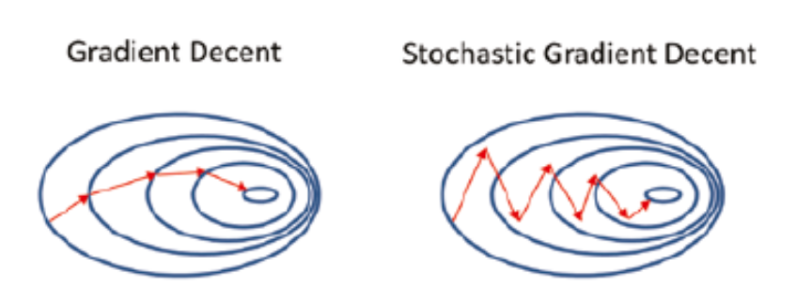

- After training, you can feed the network with a set of unseen data as input, and the network will give you a predicted output.
- Artificial neural networks usually need a lot of training and take a long time to train, but once trained, they can produce results very quickly.
- American psychologist Frank Rosenblatt developed the first artificial neural network called Perceptron in 1958, when he was working at the Cornell Aeronautical Laboratory at Cornell University in Buffalo, New York.
- Perceptron was an electronic device based on biological neural networks that had a learning capability. The main goal of Perceptron was to recognize different patterns.

